Test # 259 (Test #1)
Instrument Name Consistometer
Instrument Type Consistometer
Test Start 09/04/01 18:07
Test Stop 15:51:56
Well ID # Costa's Test#1 (H=2700m)
Customer KOGALYM
Cement Class G

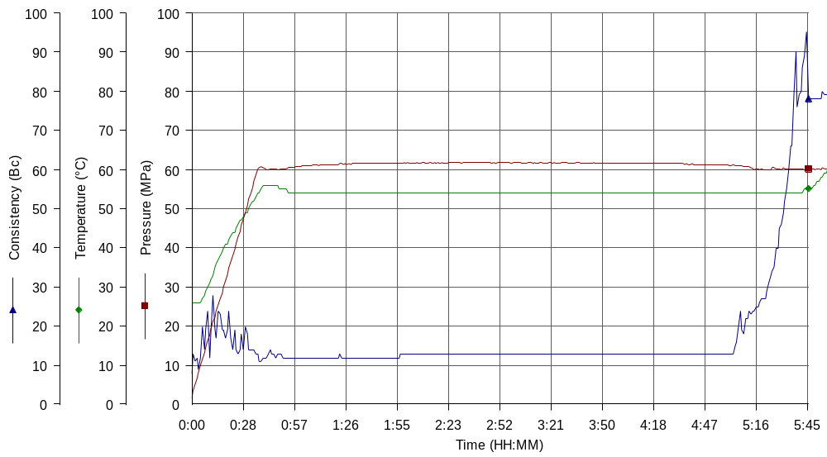

Additives 1.4%TDF-1+0.025%TR-1+Defoamer
Cement Mfr DYKERHOFF
BHCT 55
BHST 75
Density 1900
Fluid Loss 27 cc/30 min
Job Type 146 MM CSG
Comments MPa: 60 (37min); T: 55C (37min)
Tap water, Kogalym cement, Kogalym TDF-1 & TR-1, Soda Ash, Premix.

